附件一 夏令营教师简介

Rose-Hulman Institute of Technology位于美国印第安纳州Terre Haute市，成立于1874年，其前身为Rose Polytechnic Institute，是一所私立的四年制理工科类学校，仅略次于麻省理工和加州理工等，在全世界理工教育界都享有极高声誉。学院强调本科和硕士教育，在《美国新闻与世界报道》美国最佳大学排行榜中的本硕类学院中排行连续11年排名第一，并在大多数工程类学科的分类排行中也独占鳌头，包括机械工程，计算机工程，化学工程等等很多都连年夺得单项第一。学院极为重视每一位学生的学业和就业，每年毕业生都极为抢手，是真正的科学家和顶尖工程师的摇篮。本次夏令营三位教师均来自Rose-Hulman Institute of Technology，本位教师简介如下：

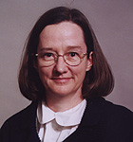 PATSY BRACKIN
Professor of Mechanical Engineering and Director of Catapult

Professor Brackin didn't consider majoring in engineering until she was filling out college applications at the end of her junior year in high school. While completing the application for the University of Tennessee, she noticed a major of Nuclear Engineering. She had read the Manhattan Project, which was a detailed account to the development of the atomic bomb, and Nuclear Engineering sounded exotic. Thanks to the encouragement of her professors, she made it through with excellent grades even though she never took chemistry or physics or calculus in high school.

After getting a B.S. and M.S., she went to work for Chicago Bridge and Iron (CBI). At that time CBI required all engineers to work at a construction site, manufacturing facility, drafting room, and design group. She was fortunate to get broad training in all of those areas, and also became a registered professional engineer. While working for CBI, she was asked to teach introductory design classes at a local college in the evenings. She agreed and discovered that she had a love for teaching. After five years at CBI, she resigned and began teaching full-time.

While teaching, she realized that it would be beneficial to get a Ph.D. Although she was tenured and had been teaching for nine years, she entered Georgia Tech in 1991 and began working on her Ph.D. The rest is history! She joined the faculty of Rose-Hulman in August of 1995, and officially received her Ph.D. in 1997. Her specialty is Design Processes with an emphasis on creative techniques. During her recent sabbatical, she was fortunate to work for Eli Lilly in Indianapolis on new product development.

 MICHAEL ROBINSON
Associate Professor of Civil and Environmental Engineering

Professor Robinson has a B.S. in Chemical Engineering from West Virginia Tech and a M.S. in Environmental Engineering and Ph.D. in Civil Engineering from Virginia Tech. He has had several jobs as a practicing engineer before finding the thing he enjoys the most - teaching engineering at Rose-Hulman. Prior to coming to Rose-Hulman, he taught at Marshall University in Huntington, West Virginia. His teaching interests are in the area of water quality, engineering software, and water treatment process design. Professor Robinson lives in Terre Haute with Ruby, his wife, and two daughters – Casey and Kendall. He enjoys spending time with his family and being a very amateur gardener.

 JIANJIAN SONG
Professor of Electrical and Computer Engineering

Professor Song is Professor of Electrical and Computer Engineering at Rose-Hulman Institute of Technology since 1999. He received his B.S. degree in radio engineering from Huazhong University of Science and Technology in Wuhan, China in 1982, and M.S. and Ph.D. degrees from the University of Minnesota in 1985 and 1991 respectively.
Since Minnesota was too cold for him, he moved to the Republic of Singapore which is 1.44 degree (or 100 miles) north of the equator. He worked for the National University of Singapore from 1991 to 1999 and held positions of Research Scientist, Senior Research Scientist and Division Manager at the National Supercomputing Research Centre, which later became the Institute of High Performance Computing (IHPC) at the National University of Singapore.
He could not bear the tropical weather of 90 degree Fahrenheit and 90% humidity all year around on the equator any longer after living there for eight years. So he moved to Indiana where the weather is just right, not too cold and not too hot.

His research interests include electromagnetic compatibility and interference, signal integrity, high-speed digital system design, microcontroller-based system design; electronic design automation

美国非博士类工科学校排名网站（Rose-Hulman已连续11年荣登榜首）http://colleges.usnews.rankingsandreviews.com/best-colleges/rankings/engineering-no-doctorate

Rose-Hulman校主页链接 www.rose-hulman.edu

下面是今年六月在Rose-Hulman校内刚刚结束的夏令营项目照片选登

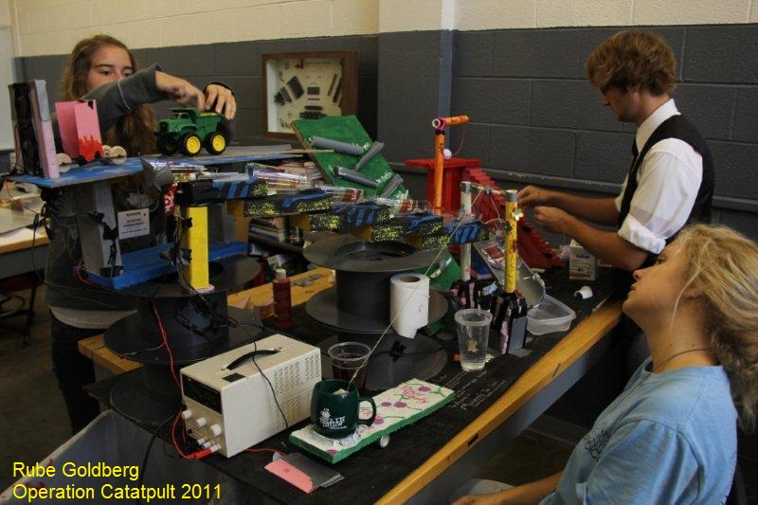
图1 Rose-Hulman学生正在制作一个Robe Goldberg 装置

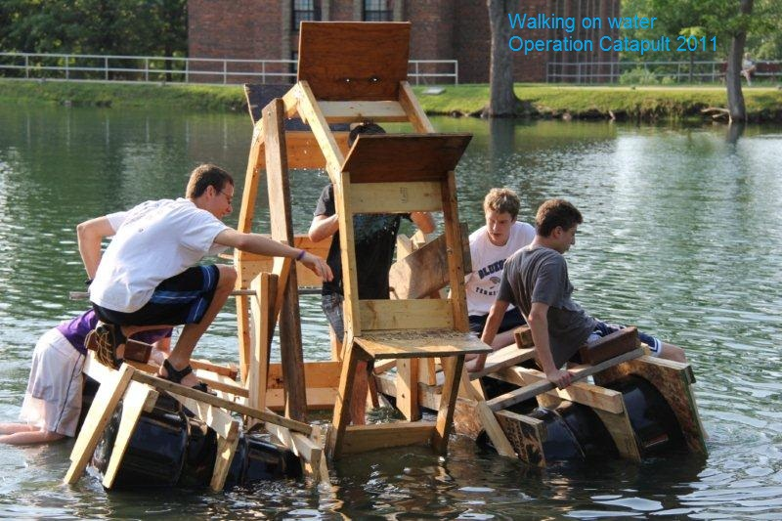
图2 Rose-Hulman的学生正在测试自制的水上行走人力装置

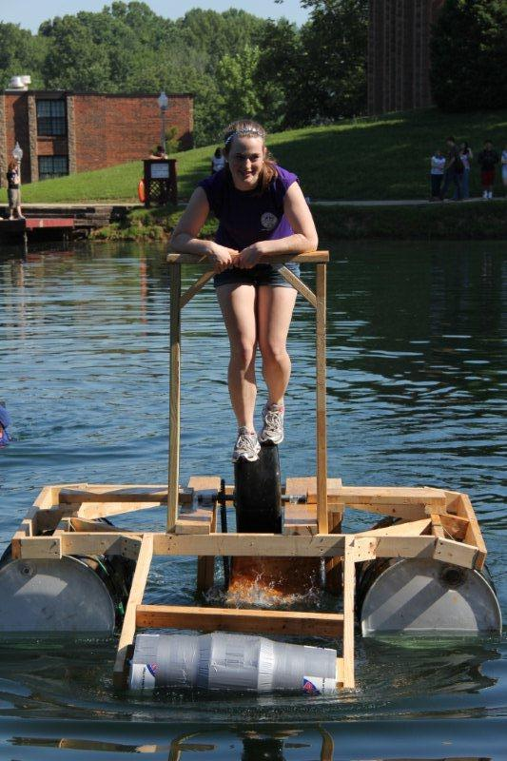
图3 水上行走人力装置

